|  |
| --- |
| **Key Knowledge** |
| * Scientists classify all living things into groups based on their characteristics. They do this so they can organise all livings things and it helps to identify them. * Living things can be grouped (classified) in different ways according to their features. Classification keys can be used to identify and name living things. * Vertebrates are animals with backbones as part of an internal skeleton. There are five main groups of vertebrates: Fish, amphibians, reptiles, birds, mammals. * Invertebrates are animals that do not have an internal skeleton. |

|  |  |
| --- | --- |
| **Key Vocabulary** | |
| **Spelling** | **Definition** |
| vertebrate | An animal which has a backbone/spine. |
| invertebrate | An animal that does not have a backbone/spine. |
| classification | To group things so that they can be identified. |
| classification key | A series of questions that helps identify or group/classify things |

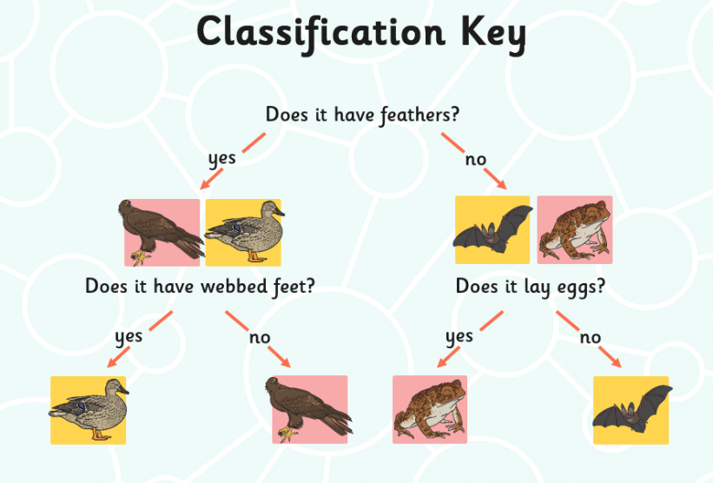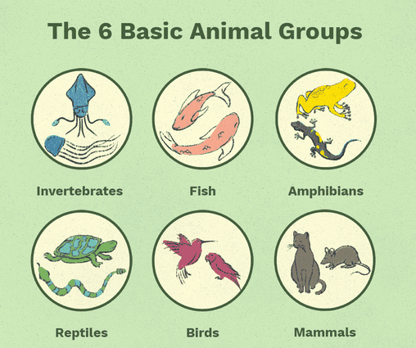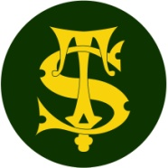

**By the end of the unit children can:**

* recognise that living things can be grouped in a variety of ways.
* explore and use classification keys to help group, identify and name a variety of living things in their local and wider environment.
* explain the characteristics of the five vertebrate groups.
* identify and explain why an animal is a fish, amphibian, reptile, bird or mammal.
* Recognise that environments can change and that this can sometimes pose dangers to living things.

Summary Statement

We will discover that plants and animals can be grouped in many different ways. Scientists use classification keys to help them to group, identify and name living things. We will begin to put invertebrate animals into groups such as worms, insects, snails, slugs and spiders.

**Science Knowledge Organiser**

Year 4

Living things and their habitats (1)