

**Science Knowledge Organiser**

**Year 4**

**Electricity**

Summary Statement

There are two main sources of electricity – mains electric and batteries. To make an electrical circuit work, children recognise that all the components (battery, wires, bulb, switches) are all connected to each other with metal touching metal, with no gaps.

**By the end of the unit children can:**

* Identify common appliances that run on electricity.
* Construct a simple series electrical circuit, identifying and naming its basic parts, including cells, wires, bulbs, switches and buzzers.
* Identify whether or not a lamp will light in a simple series circuit, based on whether or not the lamp is part of a complete circuit with a battery.
* Recognise that a switch opens and closes a circuit and associate this with whether or not a lamp lights in a simple series circuit.
* Recognise some common conductors and insulators, and associate metals with being good conductors.

battery (cell)

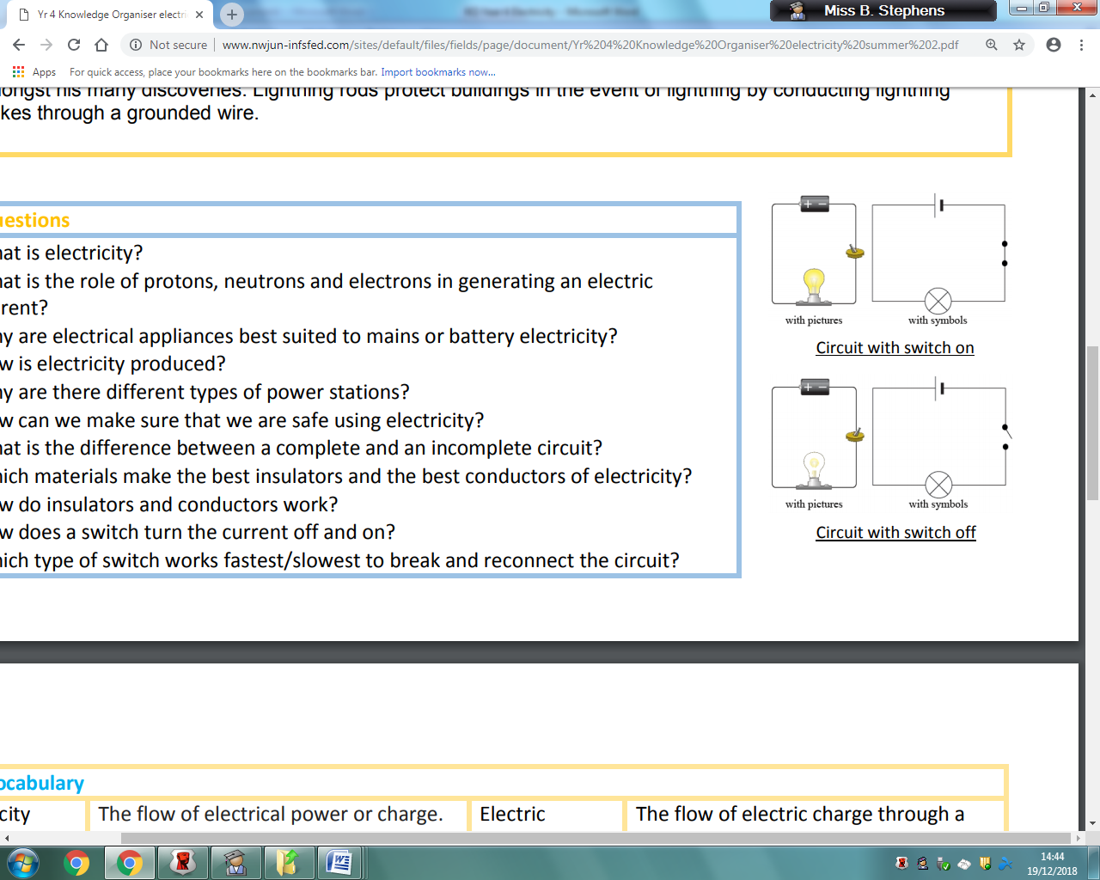

wire

switch (closed)

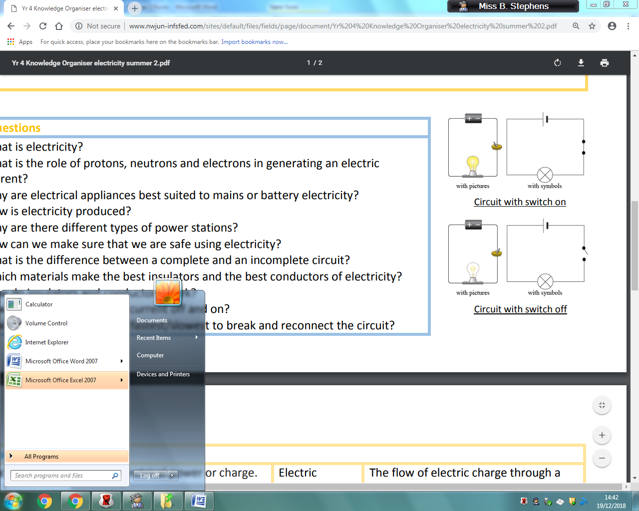

bulb

|  |
| --- |
| **Key Knowledge** |
| * Some common electrical items are powered by mains electricity like washing machines and toasters, whilst some like a torch or TV remote control need batteries. * An electrical circuit will only work if the electricity can flow through a battery from positive to negative. * Be able to construct a simple electrical circuit and draw /label this. * Switches can be used to control the flow of electricity. An open switch creates a gap in an electrical circuit so the bulb/motor/buzzer will not work. * Some materials like metal allow electricity to flow along them and we call these **electrical conductors.** * Some materials like plastics, paper, wool etc will NOT allow electricity to flow along them and we call these **electrical insulators.** |

switch (open)

|  |  |
| --- | --- |
| **Key Vocabulary** | |
| **Spelling** | **Definition** |
| Cell (battery) | A source of electricity that has a negative – terminal and positive + terminal |
| Bulb | Electrical component that lights up. |
| Buzzer | Electrical component that makes a noise. |
| Motor | Electrical component that makes something move. |
| Switch | Can be used to create a gap in a circuit and stop/control the flow of electricity. |
| Complete circuit | When components form a complete path through which electricity can flow. |
| Electrical conductor | Something that allows electricity to flow through it-metals. |
| Electrical insulator | Something that does not allow electricity to flow through it-e.g.- plastics, wool, fabric, paper and cardboard. |

