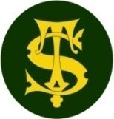

**Science Knowledge Organiser**

**Year 3**

**Animals including Humans: Skeletons and Muscles**

Summary Statement

Humans and some other animals have an internal **skeleton** made of **bone**. These animals all have a **backbone** made up of bones called **vertebrate**. These animals, including mammals, fish, birds and reptiles, are therefore called **vertebrates**. The skeleton has three functions – support, movement and protection.

**By the end of the unit children can:**

* Identify that humans and some other animals have skeletons and muscles for support, protection and movement

|  |
| --- |
| **Key Knowledge** |
| **Skeletons** do three important jobs:   1. Protect organs inside the body; 2. Allow movement; 3. Support the body and stop it from falling on the floor.  * Know that mammals have skeletons and that a human is a type of mammal. * Know what a human **skeleton** looks like. Name key parts of a skeleton .e.g. **skull, ribcage, spine.** * Know that joints occur where two bones meet and are able to move together .e.g. knee, elbow   Muscles   * Know that humans have **muscles**. * Name and locate the **bicep** and **tricep** muscle in the body. * Know that **muscles** are attached to the bone and responsible for movement. * Know that when **muscles** contract and relax, that this is what causes movement. |

|  |  |
| --- | --- |
| **Spelling** | **Definition** |
| Skeleton | Structure of bones that support the body. |
| Muscles | Soft tissues in the body that contract and relax to cause movement |
| Joints | Areas where two or more bones are fitted together |
| Vertebrate | An animal that has a back bone and a skeleton |

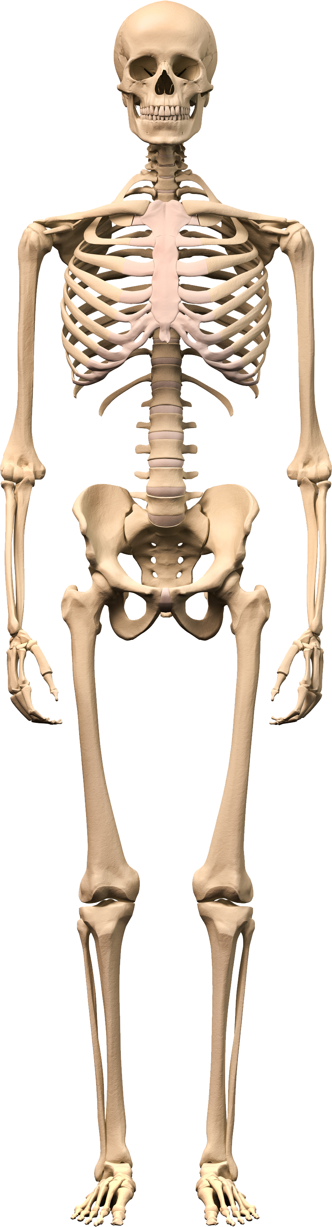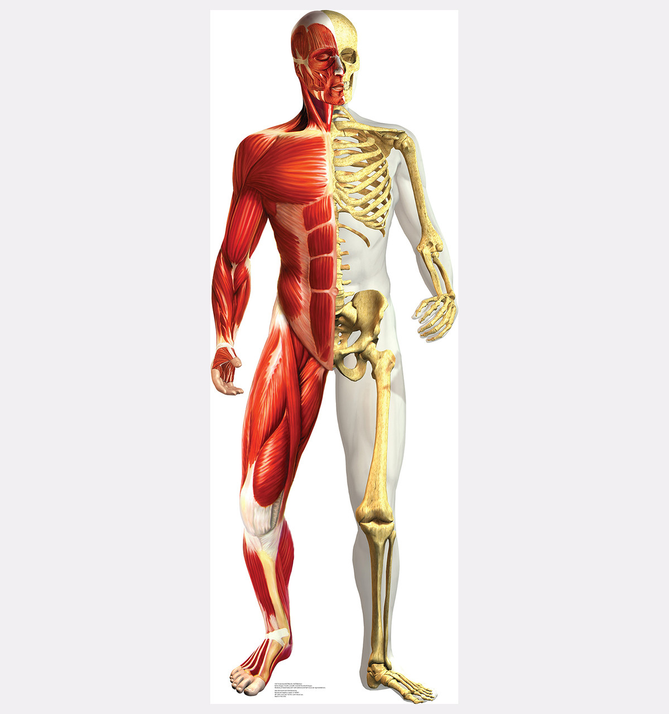

bicep

tricep

spine

ribcage

skull