|  |  |
| --- | --- |
| **Key Vocabulary** | |
| **Spelling** | **Definition** |
| durable | Something that will last a long time without breaking. |
| translucent | Something you can see through a little bit, but the image won’t be clear. |
| flexible | Easily bent without breaking. |
| rigid | Difficult or impossible to bend. |
| absorbent | Will soak up liquid or moisture. |
| brittle | An object that is hard but easily broken. |
| stretchy | Can be made longer or wider without breaking. |

|  |  |
| --- | --- |
| **Key Knowledge** | |
| Materials have different properties that make them suitable for different purposes. These materials can be sorted into groups based on their properties. | |
| We can investigate what materials are best for a purpose by looking at its properties to see if it is suitable. | |
| **Object:**  **Water Bottle** | Image result for water bottleA water bottle is made out of plastic because it is **transparent**, **waterproof**, **durable** and **rigid**. |
| **Object:**  **Coat** | A coat is made out of fabric because it is **flexible**, **soft**, **strong** and **durable**. |
| **Object:**  **Umbrella** | An umbrella is made out of plastic and metal because it is **strong**, **waterproof** and **durable**. |
| **Object:**  **Bench** | A bench ismade out of wood because it is **strong, rigid** and **durable.** |

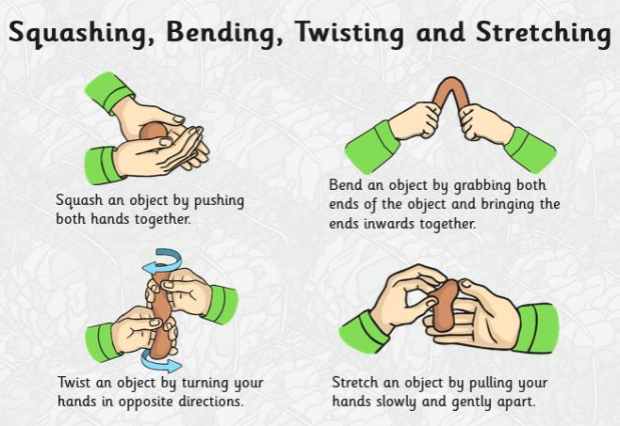

Know that materials can change shape when properties are flexible and soft but they can’t change shape when the properties are rigid, hard and stiff.

**By the end of the unit children can:**

* Identify and compare the suitability of a variety of everyday materials (including wood, metal, plastic, glass, brick, rock, paper and cardboard) for different uses.
* Find out how the shapes of **solid** objects made from some materials can be changed by squashing, bending, twisting and stretching.

Summary Statement:

All objects are made of one or more materials that are carefully chosen for a reason and purpose.

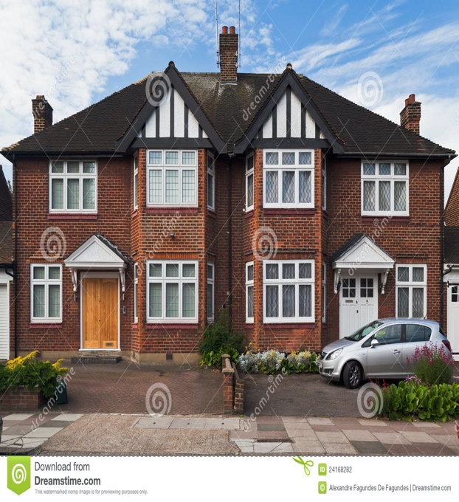

**Roof: slate or rock**

**Walls: brick**

**waterproof, durable, rigid**

**Windows: glass**

**transparent, waterproof, durable, rigid**

**waterproof, durable, rigid**

**Window frames and door: plastic**

**waterproof, protective, durable, rigid**

**Tyres: rubber**

**flexible, durable**

**Number plate: plastic**

**waterproof, flexible, durable**

**Driveway: stone**

**waterproof, durable, rigid**

**Car: metal**

**waterproof, durable, rigid, flexible**

**Science Knowledge Organiser**

**Year 2**

**Uses of Everyday Materials**