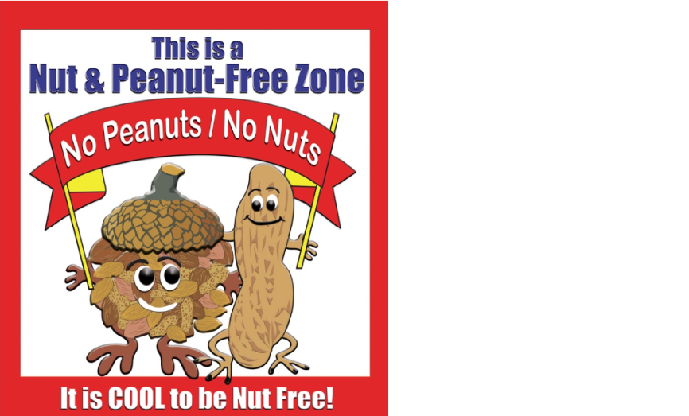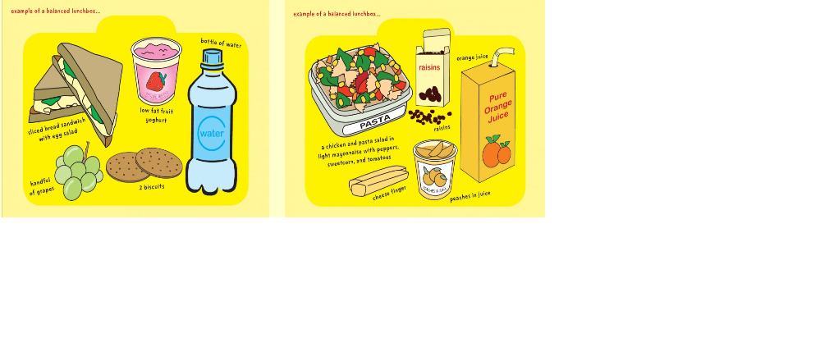

**Healthy Packed Lunches**

It is important that when providing a packed lunch for your children it is a healthy well balanced meal which will fuel them through the day.

At St Thomas of Canterbury we actively promote a healthy lifestyle and therefore we closely monitor the children’s lunches and remind the children about what to have in their lunch boxes.

We do have children in school with **SEVERE NUT ALLERGIES** and therefore ask that **NO Nuts or** **anything containing Nuts** are put into the children’s packed lunches.

When buying food and making your child’s packed lunch we would ask you to remember the following advice.

**They should include:**

* 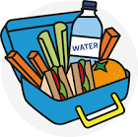At least one portion of fresh fruit
* A sandwich made with either wholemeal bread or a wrap
* Dairy food such as yoghurt, fromage fais or milk
* Only water, fruit juice, smoothies or milk drinks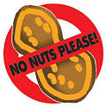
* Fresh vegetables

**They should NOT include:**

* Chocolate biscuits,sweets, crisps, waffles.
* Meat products such as sausage rolls,pasties,individual pies.
* Food that needs re-heating i.e chicken burgers, kebabs, chicken nuggets, fish fingers

***Foods such as meat on the bone(chicken drumsticks) pasta and rice should always be store below 5 $℃$ as they can easily******cause food poisoning.****Therefore it is not advisable to put them in lunchboxes. An excellent tip for keeping lunch boxes cool is to freeze a small bottle of water and put it in the lunch box. It will the defrost and be ready to drink as lunchime at the same time keeping the food fresh.*