**Geography Knowledge Organiser**

**Year 3**

The United Kingdom

|  |  |
| --- | --- |
| **Key Vocabulary** | |
| **Spelling** | **Definition** |
| county | A county is a geographical region of a country. |
| city/cities | A large human settlement. They often have a cathedral. |
| physical characteristic | Defined landforms, which have developed naturally. E.g. mountains, hills, rivers, lakes, ponds and the sea. |
| human characteristic | Land that has been developed by humans. E.g. buildings, structures and farms. |
| topographical feature | The shape and features of the surface of the land. |
| hill | A naturally raise area of land (not as high as a mountain). |
| mountain | A large, steep and naturally raised surface of the Earth. |
| river | A large, natural stream of water flowing in a channel to a body of water. |
| coast | Land that is near to or meets the sea. |
| land-use | Land that is changed by humans to suit a purpose. E.g. Settlements and arable farming. |
| farming | The use of land to grow crops to raise livestock. |

Summary Statement: Children will learn about the United Kingdom; its counties, cities, geographical regions and their identifying human and physical characteristics, key topographical features, land-use patterns and how some of these aspects have changed over time.

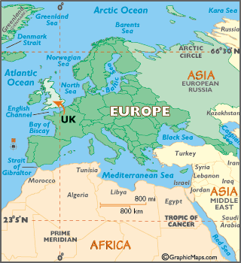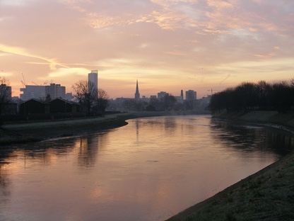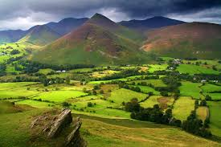

**UK Counties:**

Antrim, Tyrone, Aberdeenshire, Inverness-shire, Anglesey, Pembrokeshire, Yorkshire, Lancashire, Cheshire, Essex, Cornwall, Cumbria

**UK Cities:**

Birmingham, Liverpool, Leeds, Newcastle, Glasgow, Norwich, Inverness, Oxford, Bristol, Aberdeen

**By the end of the unit, children will be able to:**

* **Name and locate counties and cities of the United Kingdom.**
* **Locate geographical regions and identify human and physical characteristics and key topographical features of mountains and rivers.**
* **Understand about land-use patterns; and understand how some of these aspects have changed over time.**

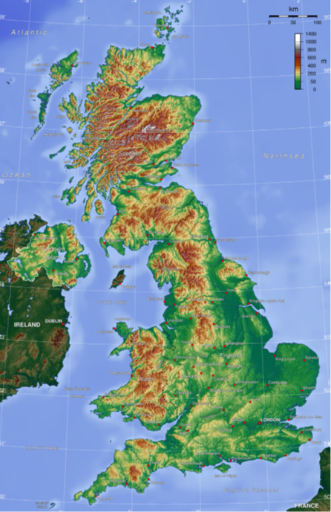

**UK Mountains:**

Ben Nevis, The Grampians, The Lake District, The Pennines, Snowdonia, The Brecon Beacons, Dartmoor

**UK Rivers:**

Thames, Mersey, Tyne, Severn, Trent, Foyle, Clyde, Humber, (Ext. Exe, Spey, Tees

**Types of UK Farming:** Arable (crops) and Pastoral (sheep and cows)