**Geography Knowledge Organiser**

**Year 2**

Contrasting Higher Broughton, UK with Chembakolli, India

Summary Statement

Children will learn to compare Higher Broughton with a small Indian village, Chembakolli.

|  |  |  |
| --- | --- | --- |
|  | Higher Broughton | Chembakolli |
| Transport | Why second-hand electric cars are the cheapest and most environmentally  friendly way to drive | Euronews | p |
| Housing | Property to rent in Higher Broughton, Salford | Placebuzzk | k |
| School | St Thomas of Canterbury Catholic Primary School, Salford M7k | l |
| Work | Higher Broughton Community Hub | Bennett Architectural Aluminium |  |

|  |  |
| --- | --- |
| **Key Vocabulary** | |
| **Spelling** | **Definition** |
| village | A community where a small amount of people live. |
| map | A drawing of a particular area. |
| compass | A device that shows direction (North, South, East and West) |
| India | A country in the continent of Asia. |
| transport | Vehicles that people use to get around or carry goods. |
| Thatched roof | Roofs made out of dead or living grass root and shoots. |

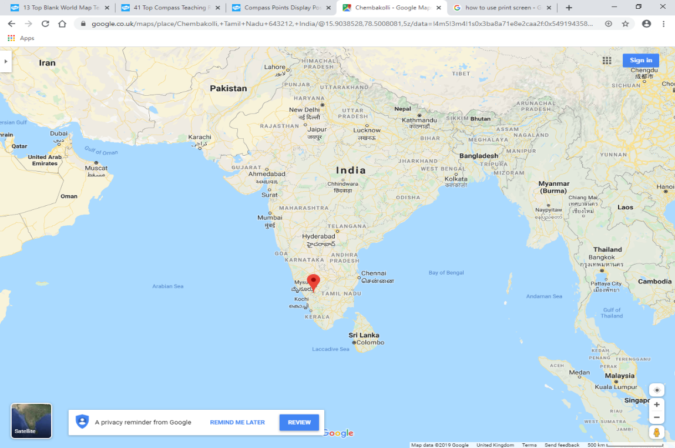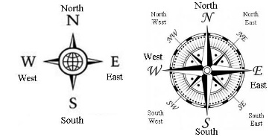

Chembakolli

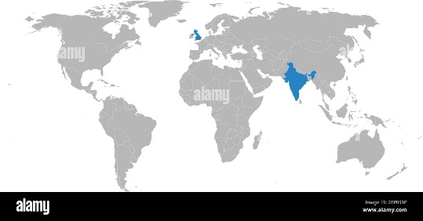

**Did you know?**

This part of India also experiences **monsoons** because most rain falls on the nearby mountains which falls down to villages like Chembakolli.

United Kingdom

India

**By the end of the unit, children will be able to:**

* Locate India and the surrounding ocean on a map.
* Use a compass to locate that Chembakolli is in the south of India.
* To understand the similarities and differences between a small village and a town.
* Make comparisons with Higher Broughton and Chembakolli in reference to transport, housing, location, schooling and day to day life.
* Understand the day to day life of a child in Chembakolli compared to our lives in Higher Broughton