
PARK RISK ASSESSMENT DATE RISK ASSESSMENT PREPARED: 7th March 2016
ACTVITY: |  | Design and Technology
VENUE : STOC
RISK ASSESSMNET OF: Round-ended scissors

LOCTION OF ACTIVITY: CLASSROOMS.

HAZARDS | CONTROL MEASURES |  | ADDITIONAL INFORMATION
Round-ended scissors | - Avoid injury by choosing tools appropriate to task and appropriate to the age and experience of the user.  - Scissors to be used to cut paper and thin card.  - Children to be made aware that the blades are sharp and could cause a pinching cut.  - Left-handed scissors should be offered to left handed children.  - Children who are likely to cause injury to themselves or others are prohibited from using scissors.  - All activities using scissors to be supervised.  - Pupils to be taught how to carry scissors- blades closed and held in a gripped palm, never carried with blades pointing outwards. |  | - Prior to use a member of staff should check the blades to ensure they are not damaged.  - Some scissors should be kept solely for the use of fabrics to keep them sharp.
 | - Pointed-ended scissors should be avoided. Only round-ended scissors should be used with pupils (one blade maybe round and the other pointed).  - DO NOT USE scissors where both blades end in a point. |  | Children and staff to be read the risk assessment before using the round-ended scissors.  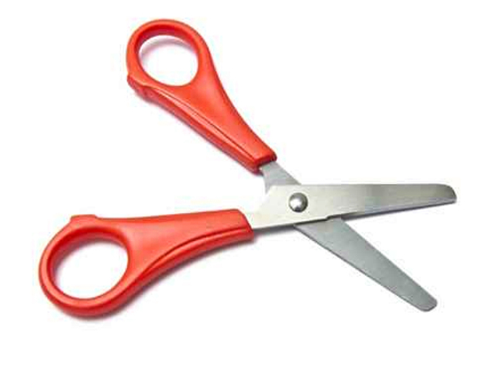

RISK ASSESSMENT PREPARED BY: Tracy Robinson
NAME OF SCHOOL: St. Thomas of Canterbury RC Primary

