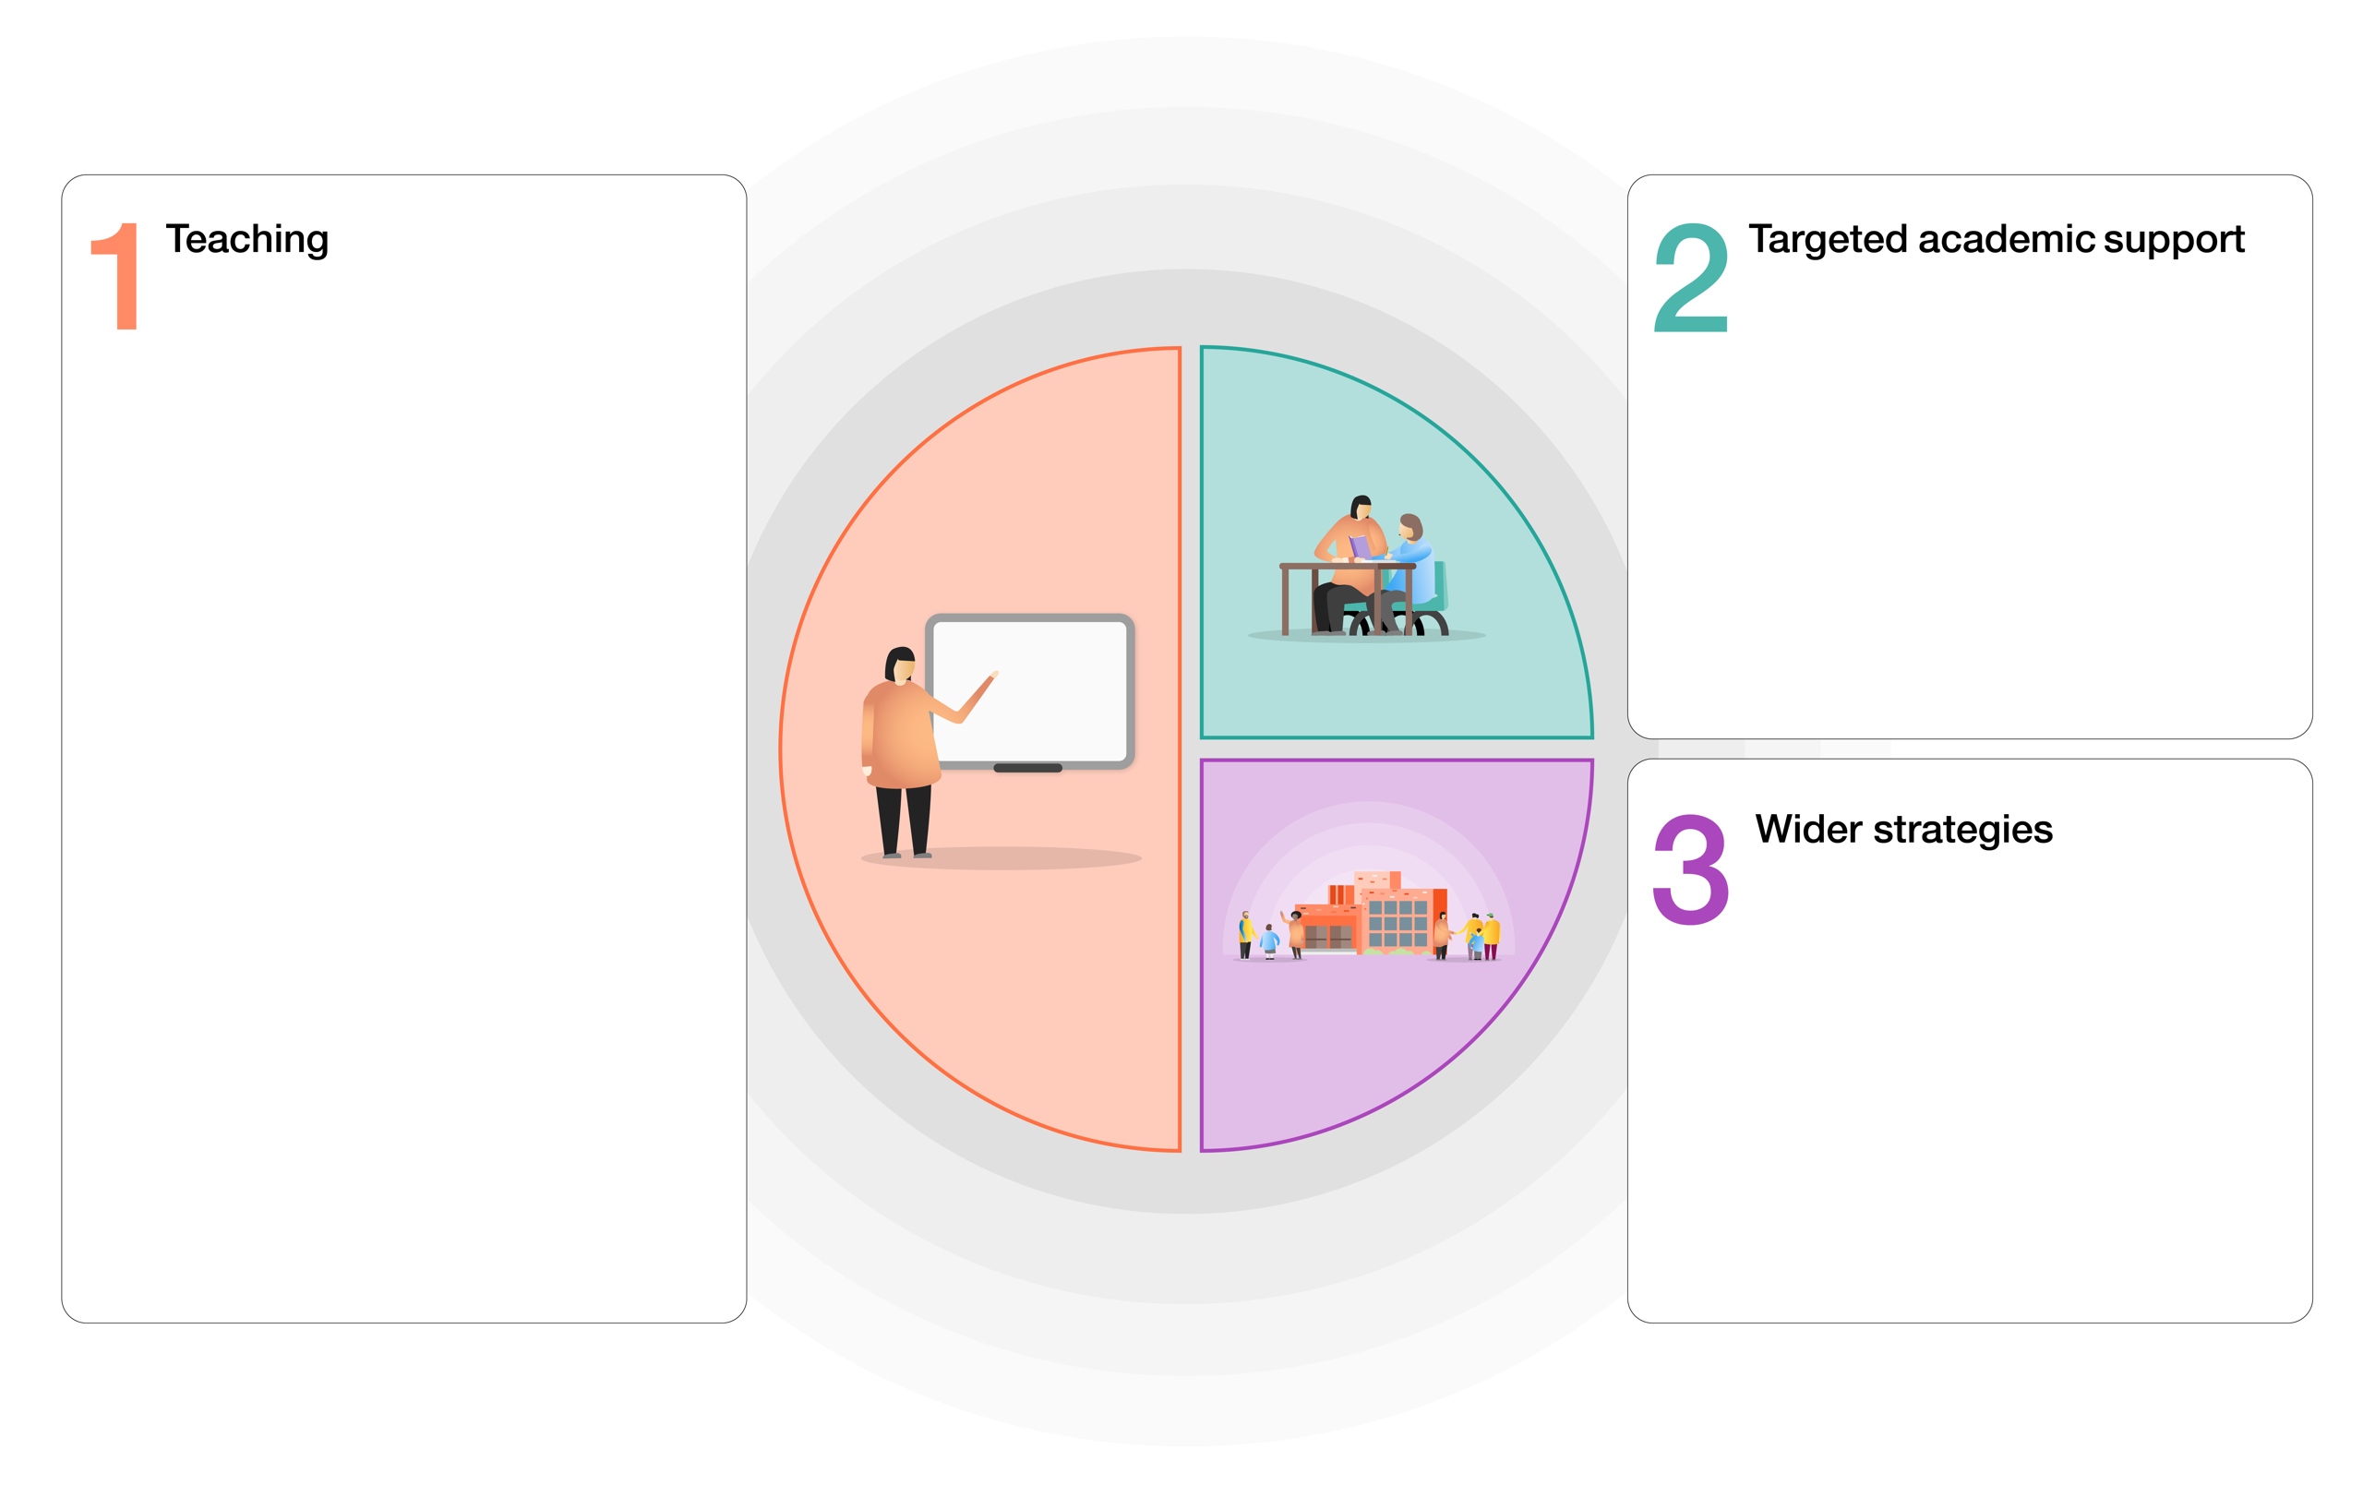

* Ensure and assure full implementation of school curriculum, with reading as its key focus.
* Ensure and assure full implementation of vast array of inclusive practices to make sure all children including the SEND and disadvantaged pupils make up their lost learning.
* Re-establish positive learning habits, including re-focusing on Growth Mindset learning powers.
* Re-start all procedures to make every child a reader – daily reading at home, use of school library, Book Talk, weekly taught comprehension, quality daily phonics, targeted readers, Reading Recovery.
* Introduce new initiatives including ‘high status’ gold, silver and bronze reading pin badges in KS2 and provide 40 book packs for most the disadvantaged.
* Target professional development of all staff on deepening further subject knowledge in core areas, in particular reading; including remote teaching and learning. Provide CPD for teachers to equip them with the knowledge and skills for closing the gap including: reading ‘Metacognition and self-related learning’ EEF Guidance Report.
* Recap and revisit training on inclusive learning strategies for those with autism and/or speech and language difficulties.
* Provide laptops and/or internet connection to allow disadvantaged pupils to access Remote Learning.
* Provide extra 30 minutes of maths/English each afternoon for coverage of missed curriculum.
* AP1 brought forward to Au1 wk7 to allow baseline. Targeted interventions from this – reading.
* Use Catch up Mondays for reading intervention.
* Reinstate Reading Recovery. Assess for additional pupils and staff accordingly.
* Produce support materials for parents to help them to close the gap. Support with parenting to then aid learning.
* Provide one to one speech and language support for pupils from N-Y6.
* Produce bespoke home-learning packs/programs for pupils with EHCPs.
* Produce bespoke home-learning packs for pupils with Speech and Language programs.

**Evaluation of expenditure**

Assess the impact of this expenditure using data, (compare Assessment Point 1-Assessment Point 3, compare phonics data to previous years, analyse SSRT data, measure Reading Recovery data).

From September 2020:

* Re-build excellent relationships between pupils, teachers and parents.
* Ensure quality first teaching – children missed clear explanations and scaffolds during lockdown so these should be the focus now.
* Maintain a broad, balanced and engaging curriculum.
* Ensure the school promotes a welcoming and safe environment.
* Provide extra PSHE time dedicated to promoting pupil talk about feelings and experiences.
* Reduce only some of the foundation curriculum, where this is deemed unsafe.
* Ensure key concepts and learning are the focus, with less vital content removed.
* Promote low-stakes testing: to encourage retrieval of knowledge; learning of key facts and concepts; promote self-study.

From October:

* Use Google Classrooms for Remote Learning to provide daily reading, writing, maths and topic. Paper-based packs available weekly. Expectation that this is completed and returned to school.
* Provide homework via Google Classrooms to improve confidence and compliance.
* Gather up to date assessment data (earlier than usual) to target children.

From January:

* Ensure Remote Learning includes daily ‘live’ sessions with the class teacher.
* Use Catch up Funding to extend the school day on Mondays by ½ an hour each week until July 2021.

From February:

* Ensure the full curriculum offer once again.

**CATCH UP FUNDING – How it is spent and how it will be evaluated (based on EEF tiered model)**

**St. Thomas of Canterbury R.C. Primary School**