

Mother’s Day Fairtrade Catalogue



It has been fairtrade fortnight!





A powerful, aromatic Organic Fairtrade dark chocolate prepared from cocoa beans harvested in the Cordillera region of the Dominican Republic and enriched with nibs of roasted cocoa beans. Truly Extra Special We have formed a unique partnership with the world-famous Leiths School of Food and Wine to create this Extra Special collection.

Ethical Statement

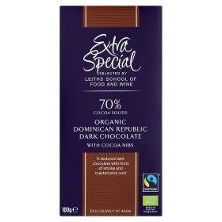We work closely with local cooperative cocoa farmers in the Cordillera region of the Dominican Republic to develop this exquisite organic chocolate. Grown in the shade of native fruit trees, our cocoa is ethically sourced to provide farmers with a Fairtrade premium which they can invest in vital water, transport and warehousing facilities. This costs £1.29

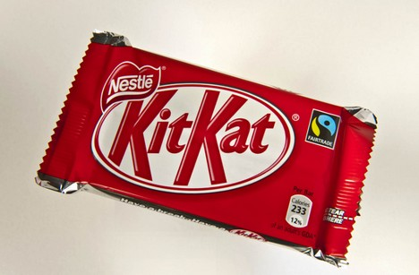

This Kit-Kat is Fairtrade because it is made by cocoa farmers in Africa. This chocolate is weak because it is only 12% of calories.

This Fair trade chocolate is £1.00

Fair trade is where the farmers who made the product gets the right deal of money.

The two-finger kit kat has become the second most popular Fair trade product in the UK, providing an income for thousands more farmers in Ivory Coast, where more than 40% of the world's cocoa is produced.

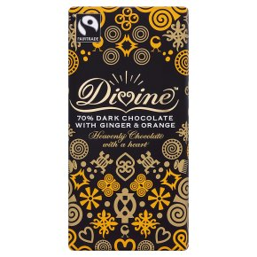Divine chocolate is made only with the finest quality Fairtrade cocoa beans from Kuapa Kokoo, a co-operative of smallholder farmers in Ghana. The cocoa is grown in the shade of the tropical rainforest, and slowly fermented and dried in the sun by the farmers, who take great pride in the chocolate company they co-own. Choosing delicious Divine gives you guaranteed pleasure, and the farmers a guaranteed fair deal, as well as the chance to invest in a better future - that's good business. Read the story of Divine on the inside of the wrapper, it costs £1.50.

**Other Fair Trade chocolate products available are:**

[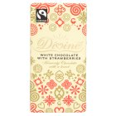](http://www.waitrose.com/shop/DisplayProductFlyout?productId=202377)

White chocolate with strawberries

100g

£1.50

Available at Waitrose

Green and blacks fair-trade organic Maya gold dark chocolate

100g

£2.00

Available at Waitrose

[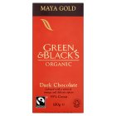](http://www.waitrose.com/shop/DisplayProductFlyout?productId=4785)

[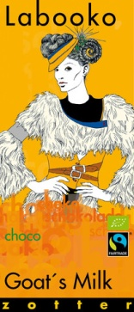](http://www.chocolatiers.co.uk/products/zotter-goats-milk-chocolate)

Zotter Goat’s milk Chocolate

100g

£3.00

Available online from www.zotterchocolate.co.uk

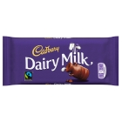

Cadbury’s dairy milk

120g

RRP £1.39

Available from most supermarkets

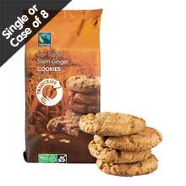

**Ginger cookies are 200 grams .It does not contains hydrogenated oil .This is suitable for vegetarians.**

**Other Fair Trade biscuit products available are:**

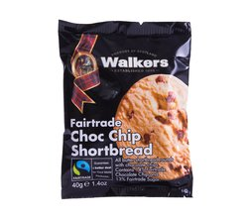

Fairtrade chocolate chip shortbread

40g

Packets available from £1.85

Available from www.walkersshortbread.com



Fairtrade fortune cookies

Price depends on quantity ordered

Available from www.cookie-4u.com

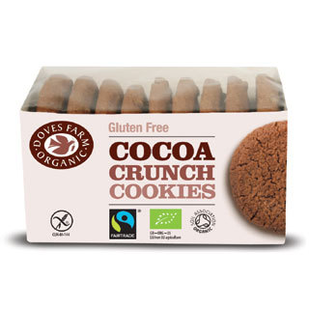

Tradecraft fair-trade dark chocolate coated ginger biscuits gift box

200g

£3.95

Available from www.tradecraftshop.co.uk

Gluten free cocoa crunch cookies

150g

£1.59

Available from www.dovesfarm.co.uk

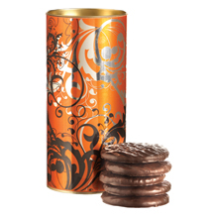

Fairtrade is important, because in poor countrys workers dont get much money but with Fairtrade workers earn a fair wage.

On dairy milk chocolate wrapppers there are fairtrade signs on it and on other products too.



These Spring flowers are professionally arranged, hand-tied and presented in a beautiful wrap. These flowers will be delivered in an elegant box. A card is also included which will present your personal message.  
  
To ensure your flowers last a bit longer some flowers will arrive in bud. Please see your postal box for more care instructions. These cost £18.00 with free delivery

**Other Fair Trade flowers available are:**

[](http://www.marksandspencer.com/fairtrade-22-white-roses/p/p21037764)

22 White roses

£25

Available from Marks and Spencer

[](http://interflora-uk.resultspage.com/search?p=R&srid=S8-UKLD02&lbc=interflora-uk&w=fairtrade&url=http://www.interflora.co.uk/catalog/product.xml?product_id=2541904;&rk=4&uid=171074058&sid=17&ts=v5&rsc=DkETiNHNmc0-SlxC&method=and&filter=type:products&view=grid&isort=score)

Hand tied fair-trade Sunny days bouquet

£29.99

Available from Interflora

[](http://www.asda-flowers.co.uk/dutch-mixed-tulips-flowers-by-post.html)

Mixed Tulips

£17 with free delivery

Available from ASDA

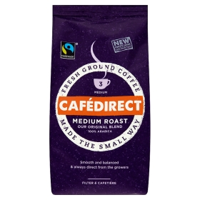

Coffee is a fair-trade product.

You can drink it.

This is a £3.00 product.

Fair trade is where the farmer

Who get the right reward for their

hard work.

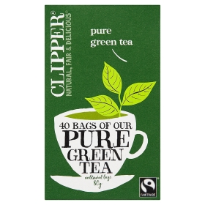

This is a picture of light, refreshing & clean-tasting unbleached bags of green tea. It is also a fair-trade product. The price of this green tea is £1.48 in Asda. A natural source of antioxidants.

Fair-trade is about giving the farmers the right amount of money that they need.

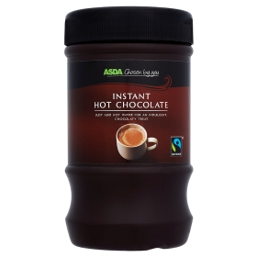This instant fair trade hot chocolate is for sale for £1.58. Fair trade is for the farmer. Just add hot water for an indulgent, chocolaty treat. No artificial colours or flavours. Instant hot chocolate drink made with Fairtrade sugar and Fairtrade cocoa. Fairtrade enables farmers and workers in developing countries to improve their working and living conditions and encourages environmental protection.

**Other Fair Trade drinks available are:**

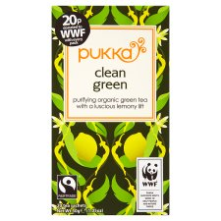

Pukka Clean green organic

20 tea bags

£2.49

Available at TESCO

Extra special Columbian Fairtrade coffee beans

227g

£2.50

Available at ASDA

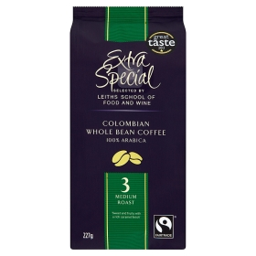

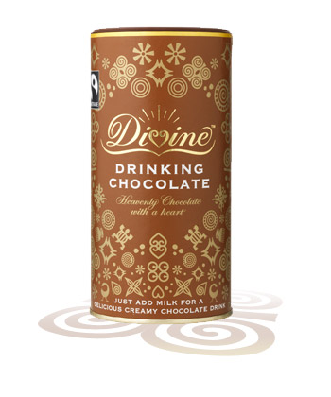

Divine Drinking chocolate

400g

£3.50

Available at www.divinechocolate.com

This is a fair trade dress and you can tell by looking at the symbol on the back of its inside

Fair trade is when the farmers do all their hard work to earn money

[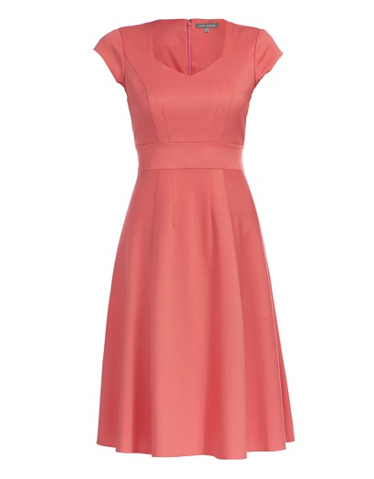](http://www.lauraashley.com/content/ebiz/lauraashley/invt/md818/md818_hotcoralmulti_lalt3.jpg)

**Other Fair Trade clothes available are:**

**[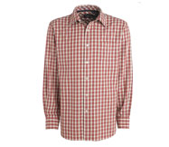](http://www.debenhams.com/)**

Checked Shirt

Available at Topman

Price start at £20

**[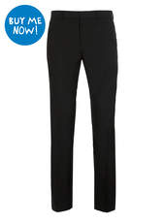](http://www.topman.com/webapp/wcs/stores/servlet/ProductDisplay?catalogId=33056&storeId=12555&productId=1289176&langId=-1)**

Skinny trouser

Other colours available

£25

Available at Topman

[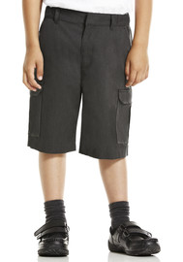](http://www.clothingattesco.com/f+f-signature/f+f-signature-boys-cargo-shorts-with-fairtrade-cotton/invt/ag211502)

F&F Signiture cotton Cargo shorts

Prices start at £7 depending on size

Avaiable from TESCO

Boots offer a range of fairtrade toiletries:

[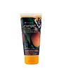](http://www.boots.com/en/Boots-Extracts-Fairtrade-Mango-Body-Wash-200ml_998329/)£8.00

[**Boots Extracts Fairtrade Mango Body Wash 200ml**](http://www.boots.com/en/Boots-Extracts-Fairtrade-Mango-Body-Wash-200ml_998329/)

5670446

[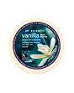](http://www.boots.com/en/Boots-Extracts-Fairtrade-Vanilla-Body-Butter-200ml_998737/)£4.50

[**Boots Extracts Fairtrade Vanilla Body Butter 200ml**](http://www.boots.com/en/Boots-Extracts-Fairtrade-Vanilla-Body-Butter-200ml_998737/)

5671728

[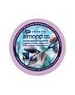](http://www.boots.com/en/Boots-Extracts-Fairtrade-Almond-Body-Scrub-400ml_998745/)£8.00

[**Boots Extracts Fairtrade Almond Body Scrub 400ml**](http://www.boots.com/en/Boots-Extracts-Fairtrade-Almond-Body-Scrub-400ml_998745/)

5673534

[](http://www.boots.com/en/Boots-Extracts-Fairtrade-Mango-Sugar-Scrub-400ml_998331/)£8.00

[**Boots Extracts Fairtrade Mango Sugar Scrub 400ml**](http://www.boots.com/en/Boots-Extracts-Fairtrade-Mango-Sugar-Scrub-400ml_998331/)

5673577

[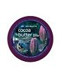](http://www.boots.com/en/Boots-Extracts-Fairtrade-Cocoa-Butter-Body-Butter-200ml_998719/)£8.00

[**Boots Extracts Fairtrade Cocoa Butter Body Butter 200ml**](http://www.boots.com/en/Boots-Extracts-Fairtrade-Cocoa-Butter-Body-Butter-200ml_998719/)

5671701

[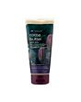](http://www.boots.com/en/Boots-Extracts-Fairtrade-Cocoa-Butter-Body-Wash-200ml_998316/)

[**Boots Extracts Fairtrade Cocoa Butter Body Wash 200ml**](http://www.boots.com/en/Boots-Extracts-Fairtrade-Cocoa-Butter-Body-Wash-200ml_998316/)

5670403

[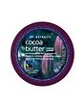](http://www.boots.com/en/Boots-Extracts-Fairtrade-Cocoa-butter-sugar-scrub-400ml_997802/)£8.00

[**Boots Extracts Fairtrade Cocoa butter sugar scrub 400ml**](http://www.boots.com/en/Boots-Extracts-Fairtrade-Cocoa-butter-sugar-scrub-400ml_997802/)

[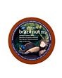](http://www.boots.com/en/Boots-Extracts-Fairtrade-Brazil-Nut-Body-Scrub-400ml_998325/)£8.00

[**Boots Extracts Fairtrade Brazil Nut Body Scrub 400ml**](http://www.boots.com/en/Boots-Extracts-Fairtrade-Brazil-Nut-Body-Scrub-400ml_998325/)

5673569