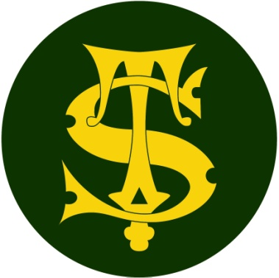

Headline Data 2024

Here at St Thomas of Canterbury we are proud of all of the achievements of the children at our school but do not define success simply as children passing an assessment at the end of a particular phase of education.

Our broad and balanced curriculum is constructed to meet the needs of all our learners in our specific school context. The curriculum is designed to be progressive, building logically and methodically on pupil’s prior learning.

We thank all of our fantastic staff and parents for supporting the children to achieve so well.

HEADLINES ATTAINMENT 2024
End of KS2 (Year 6) results
 | Reading | High Reading | SPAG | High SPAG | Maths | High Maths | Writing | High Writing | Combined | High Combined
School %  2024 | 93% | 48% | 95% | 59% | 97% | 61% | 85% | 31% | 84% | 23%
National %  2024 | 74% | % | 72% | % | 73% | % | 72% | % | 61% | %
Difference | +19% | % | +23% | % | +24% | % | +13% | % | +23% | %
SToC 2023 | 90% | 38% | 90% | 50% | 97% | 53% | 93% | 23% | 90% | 18%
 | Reading |  | SPaG |  | Maths
Average scaled score (school) 2024 | 109.1 |  | 107.6 |  | 110.8
National scale score  2024 | 105 |  | 105 |  | 104
Difference | +4 |  | +2 |  | +6

HEADLINES ATTAINMENT 2024 – End of KS1 (Year 2) Results
 | Reading  EXP | Reading  GDS | Maths  EXP | Maths  GDS | Writing  EXP | Writing  GDS
School %  2024 | 75% | 13% | 73% | 13% | 67% | 7%
National %  2024 | 69% |  | 72% |  | 61%
Difference | +6% |  | +1% |  | +6%
SToC 2023 | 71% | 15% | 75% | 15% | 65% | 8%
*Fisher Family Trust data- national figures

End of Year 1 – Phonics Screening check results – June 2024
Year 1
Number | School 2024 | National | Difference
58 out of 59 passed the phonics screening check | 98% | *
*PSC national data was 79% in 2023
NB One pupils with an Educational Health Care Plan (EHCP) did not pass the phonics screening check ( scored 26 marks). This child is on track to pass in Year2 with appropriate school support.

Excluding this one high level Special Needs pupils, the pass rate was 100%

The pass mark was 32 out of 40 marks. The lowest score at St Thomas of Canterbury was 33, the median score was 37 marks.

