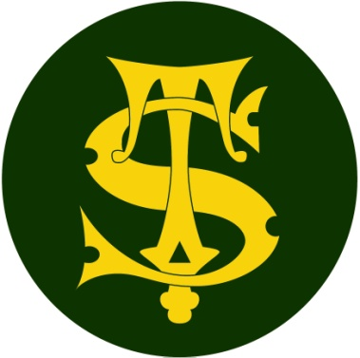

Headline Data 2023

Here at St Thomas of Canterbury we are proud of all of the achievements of the children at our school but do not define success simply as children passing an assessment at the end of a particular phase of education.

Our broad and balanced curriculum is constructed to meet the needs of all our learners in our specific school context. The curriculum is designed to be progressive, building logically and methodically on pupil’s prior learning.

We thank all of our fantastic staff and parents for supporting the children to achieve so well.

HEADLINES ATTAINMENT 2023
End of KS2 (Year 6) results
 | Reading | High Reading | SPAG | High SPAG | Maths | High Maths | Writing | High Writing | Combined | High Combined
School %  2023 | 90% | 38% | 90% | 50% | 97% | 55% | 93% | 23% | 90% | 18%
National %  2023* | 73% | % | 72% | % | 73% | % | 71% | % | 59% | %
Difference | +17% | % | +18% | % | +24% | % | +22% | % | +31% | %
SToC 2022 | 95% | 34% | 91% | 45% | 94% | 46% | 93% | 20% | 85% | 18%
 | Reading |  | SPaG |  | Maths
Average scaled score (school) 2023 | 108 |  | 109 |  | 110
National scale score  2023 | 105 |  | 105 |  | 104
Difference | +3 |  | +4 |  | +6

HEADLINES ATTAINMENT 2023 – End of KS1 (Year 2) Results
 | Reading  EXP | Reading  GDS | Maths  EXP | Maths  GDS | Writing  EXP | Writing  GDS
School %  2023 | 75% | 13% | 73% | 13% | 67% | 7%
National %  2023 | 69% |  | 72% |  | 61%
Difference | +6% |  | +3% |  | +6%
SToC 2022 | 71% | 15% | 75% | 15% | 65% | 8%
*Fisher Family Trust data- national figures

Year 1
Phonics Screening Check 2023
Number | School 2023 | National | Difference
60 out of 64 passed the phonics screening check | 94% | *
*PSC national data has not yet been released.

NB Four pupils with Educational Health Care Plans (EHCPs) did not take the phonics screening check.
Excluding these four high level Special Needs pupils the pass rate was 100%
The pass mark was 32 out of a possible 40 marks. The lowest score at St Thomas of Canterbury was 34 marks.

There were no Year 2 retakes in 2023.

