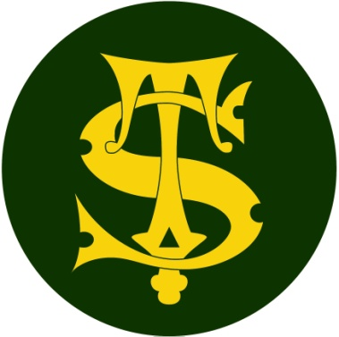

Headline Data 2022

Here at St Thomas of Canterbury we are proud of all of the achievements of the children at our school but do not define success simply as children passing an assessment at the end of a particular phase of education.

Our broad and balanced curriculum is constructed to meet the needs of all our learners in our specific school context. The curriculum is designed to be progressive, building logically and methodically on pupil’s prior learning.

We thank all of our fantastic staff and parents for supporting the children to achieve so well.

HEADLINES ATTAINMENT 2022 -End of KS2(Year 6) results
 | Reading | High Reading | SPAG | High SPAG | Maths | High Maths | Writing | High Writing | Combined | High Combined
School %  2022 | 97% | 34% | 91% | 45% | 95% | 46% | 89% | 20% | 85% | 17%
National %  2022 | 74% | 28% | 72% | 26% | 71% | 21% | 69% | 10% | 59% | 6%
Difference | +23% | +6% | +19% | +19% | +24% | +25% | +20% | +10% | +36% | +11%
Average scaled score (school) 2022 | 108 |  | 109 |  | 109
National scale score  2022 | 105 |  | 105 |  | 104
Difference | +3 |  | +4 |  | +5
Average progress score | Reading | Writing | Maths
 | Not published yet | Not published yet | Not published yet

HEADLINES ATTAINMENT 2022 –End of KS1 (Year 2) Results
 | Reading | High Reading | Maths | High Maths | Writing | High Writing | Combined | High Combined
School %  2022 | 71% | 15% | 75% | 15% | 65% | 8% | 66% | 7%
National %  2022 | 68% | 18% | 68% | 15% | 58% | 8% | 54% | 6%
Difference | +3% | -3% | +7% | +0% | +7% | +0% | +12% | +1%

Phonics Screen 2022- Year 1

 | Number | School 2022 | National | Difference
 | 61 out of 63 passed the phonics check | 97% | 76% | +21%
NB Two pupils with Educational Health Care Plans (EHCPs) did not take the phonics screening check.
Excluding these two high level Special Needs pupils the pass rate was 100%
The pass mark was 32 out of a possible 40 marks. The lowest score at St Thomas of Canterbury was 35 marks.

