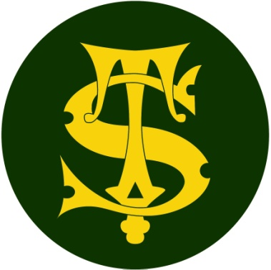

Headline Data 2019

Here at St Thomas of Canterbury we are proud of all of the achievements of the children at our school but do not define success simply as children passing an assessment at the end of a particular phase of education.

Our broad and balanced curriculum is constructed to meet the needs of all our learners in our specific school context. The curriculum is designed to be progressive, building logically and methodically on pupil’s prior learning.

We thank all of our fantastic staff and parents for supporting the children to achieve so well.

HEADLINES ATTAINMENT 2019 -End of KS2(Year 6) results
 | Reading | High Reading | SPAG | High SPAG | Maths | High Maths | Writing | High Writing | Combined | High Combined
School %  2019 | 92% | 23% | 95% | 60% | 94% | 40% | 92% | 20% | 89% | 14%
National %  2018 | 75% | 28% | 78% | 34% | 76% | 24% | 78% | 20% | 64% | 10%
Difference | +17% | -5% | +17% | +26% | +18% | +16% | +14% | 0% | +25% | +4%
Average scaled score (school) 2019 | 106 |  | 111 |  | 108
National scale score  2018 | 105 |  | 106 |  | 104
Difference | +1 |  | +5 |  | +4
Average progress score | Reading | Writing | Maths
 | 2.3 | 1.7 | 3.1

HEADLINES ATTAINMENT 2019 –End of KS1 (Year 2) Results
 | Reading | High Reading | Maths | High Maths | Writing | High Writing | Combined | High Combined
School %  2019 | 82% | 27% | 80% | 27% | 77% | 18% | 79% | 24%
National % | 75% | 26% | 76% | 22% | 70% | 16% | 65% | 12%
Difference | +7% | +1% | +4% | +5% | +7% | +2% | +14% | +12%

Phonics Screen 2019 - Year 1

 | Number | School 2019 | National | Difference
 | 61 | 86% | 82% | +4%

Early Years Foundation Stage Early Learning Goals – 2019
End of Reception class results
 | Pupils |  | % at  Good Level of  Development 2019 | National | Difference
 | No. | % | % at  Good Level of  Development 2019 | National | Difference
All Pupils | 66 |  | 70% | 72% | -2%

